Браузеры: Google Chrome, Microsoft Edge, Yandex.

**ID: 001**

Summary: Comments don’t show up.

Enviroment: Windows 10, Microsoft Edge

Severity: Trivial

Priority: Low

Assignee: Мядель Тимофей Дмитриевич

Steps to reproduce: 1. Go to main page <https://wildlife.by/>

2. Scroll the page to the mid

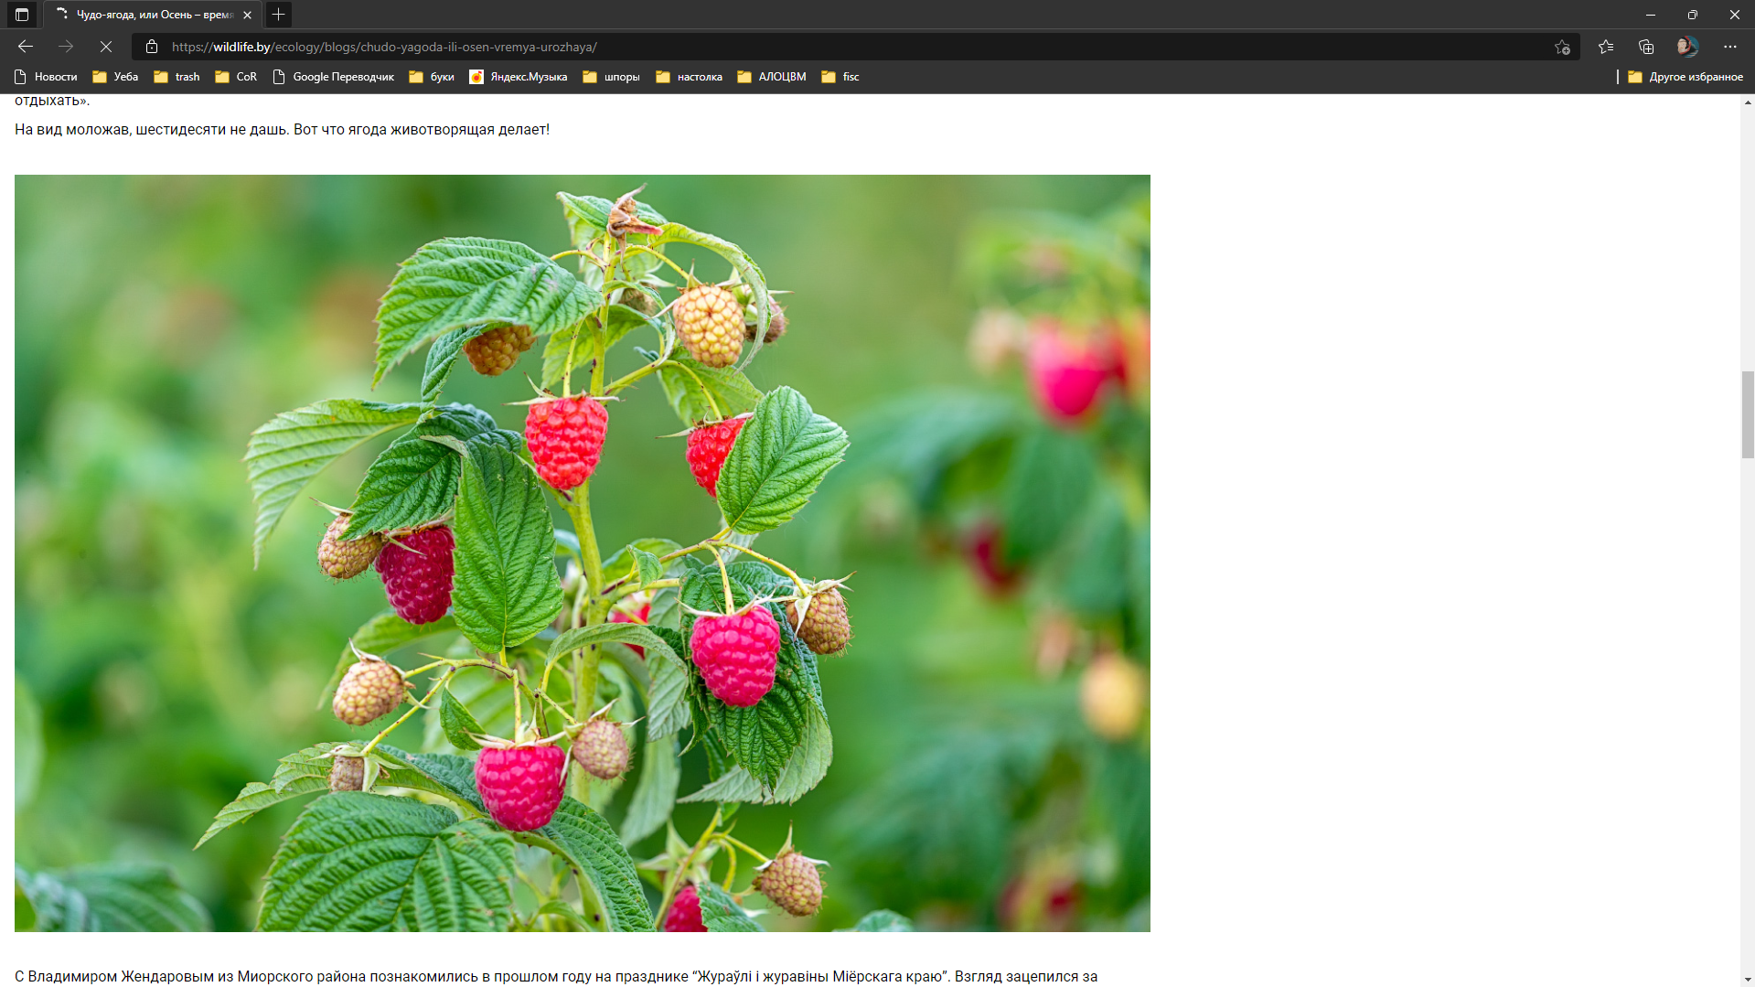  
Enviroment: Windows 10, Google Chrome

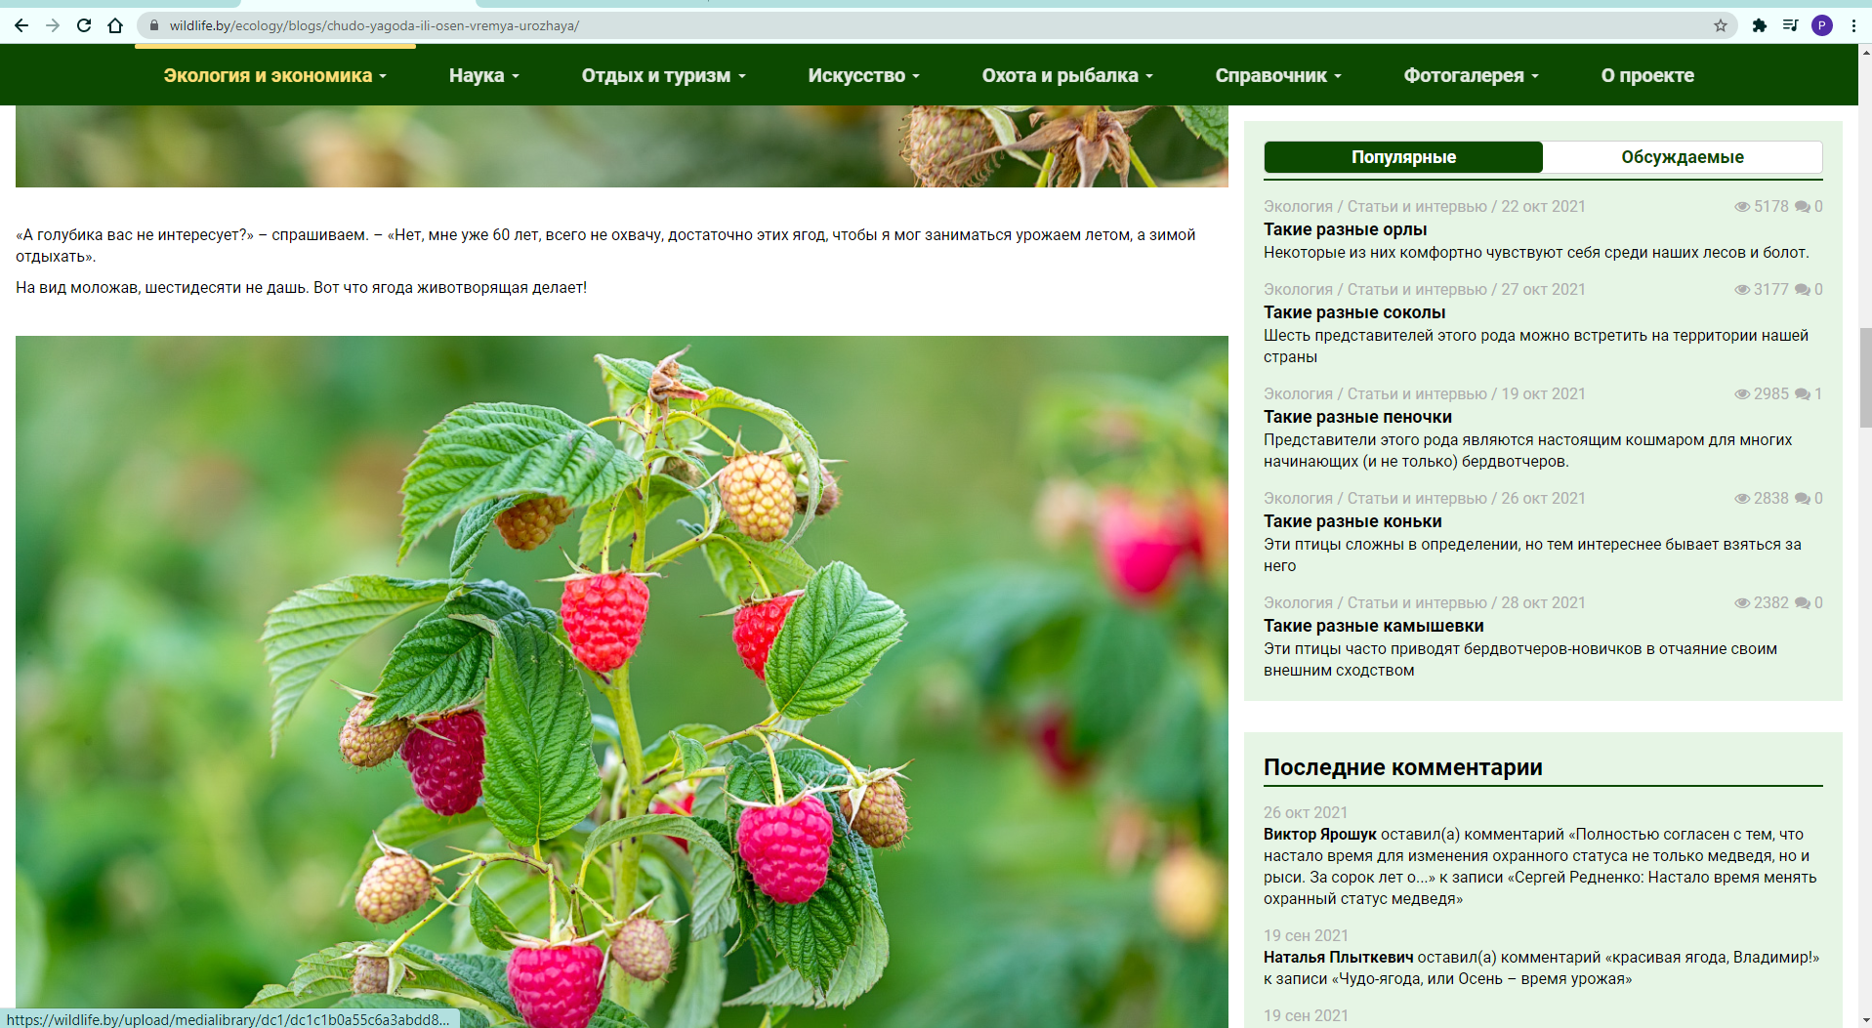

**ID: 002**

Summary: “О проекте” overlaps post text

Enviroment: Windows 10, Microsoft Edge

Severity: Trivial

Priority: Low

Assignee: Мядель Тимофей Дмитриевич

Steps to reproduce: 1. Go to main page <https://wildlife.by/>

2. Scroll the page to the mid

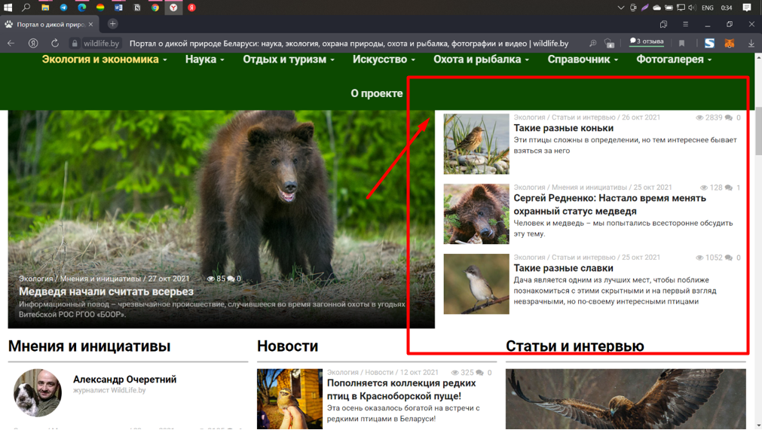

**ID: 003**

Summary: Different menu

Enviroment: Windows 10, Yandex browser

Severity: Trivial

Priority: Low

Assignee: Мядель Тимофей Дмитриевич

Steps to reproduce: 1. Go to main page <https://wildlife.by/>

2. Enlarged the page  
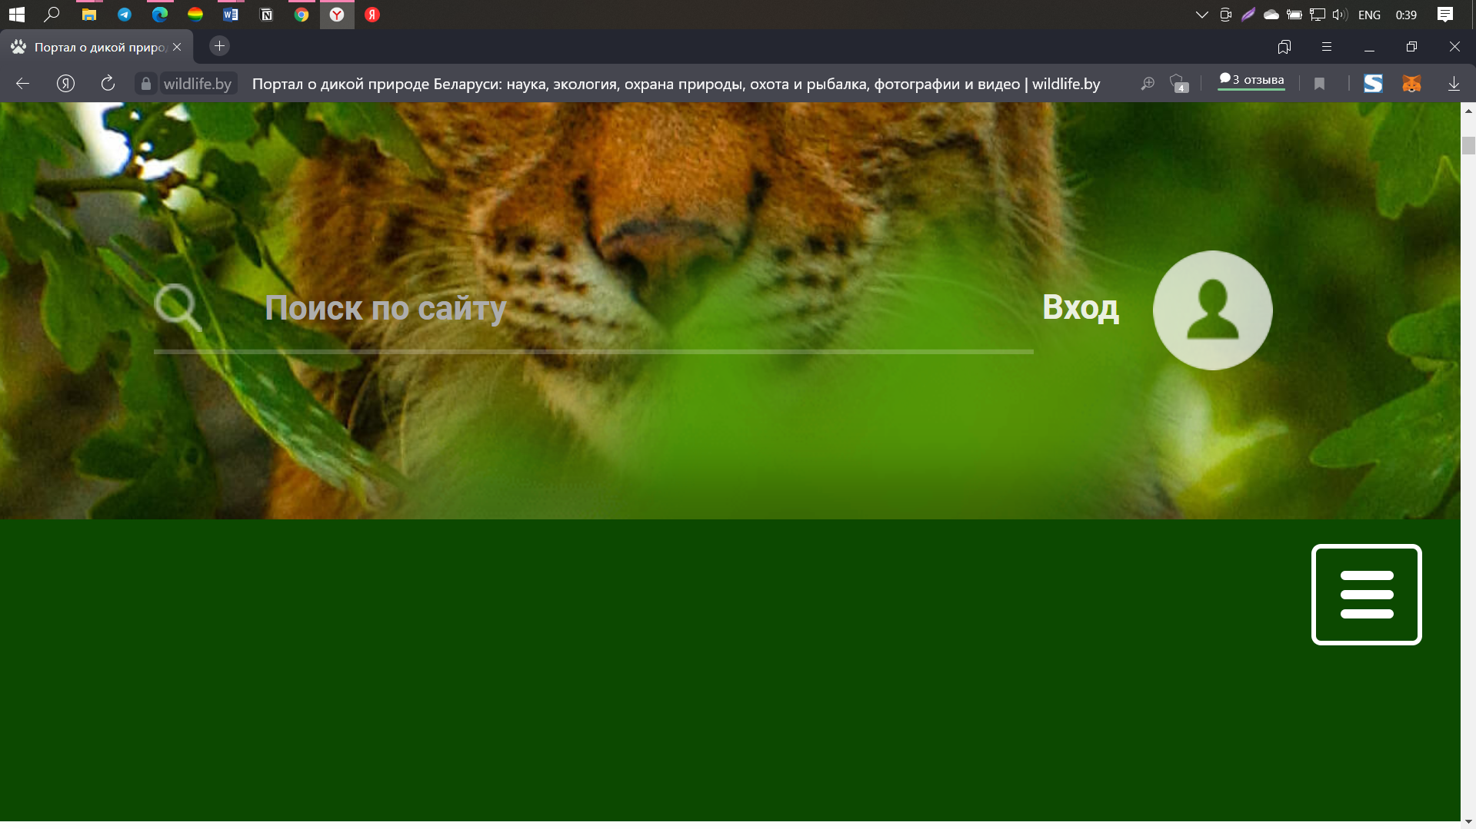  
Enviroment: Windows 10, Google Chrome

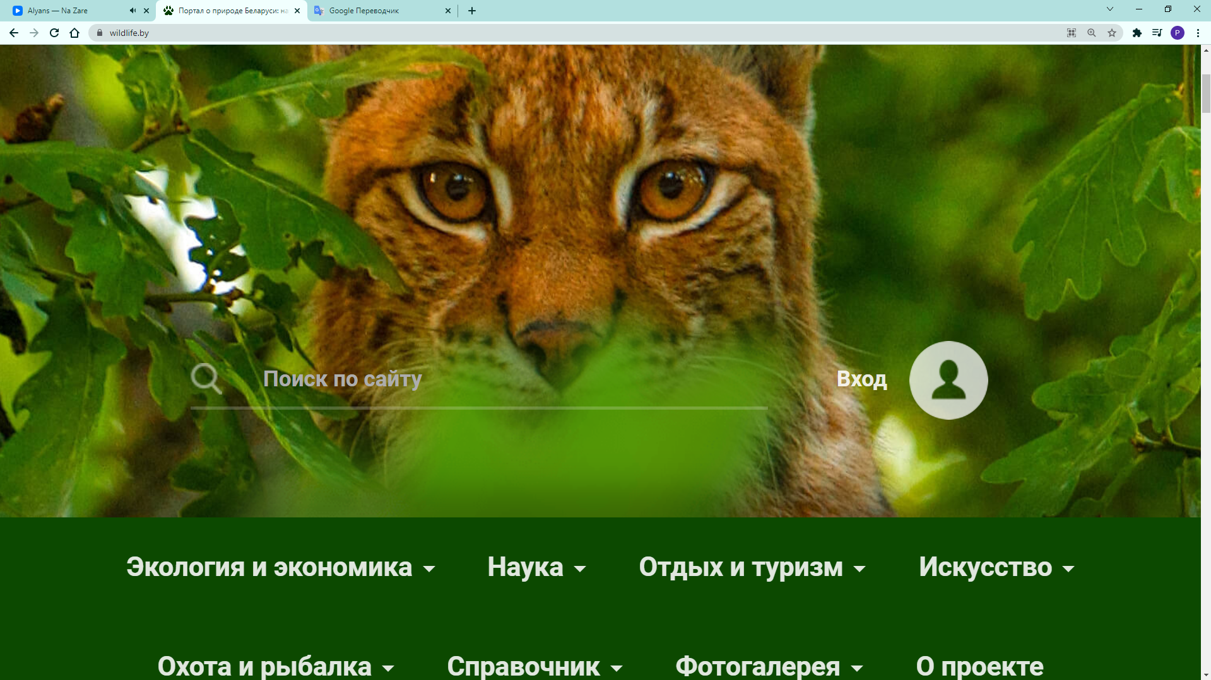  
  
**ID: 004**

Summary: Menu overlaps post text

Enviroment: Windows 10, Yandex Browser

Severity: Trivial

Priority: Low

Assignee: Мядель Тимофей Дмитриевич

Steps to reproduce: 1. Go to main page <https://wildlife.by/>

2. Scroll the page to the mid

3. Click menu

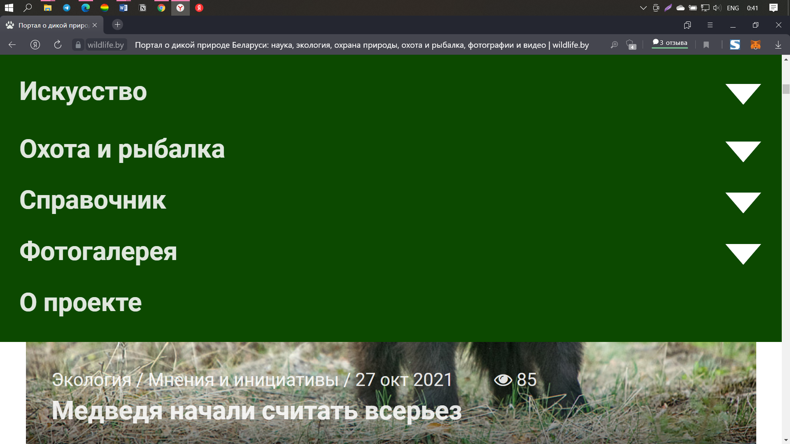

**ID: 005**

Summary: VK didn’t connected

Enviroment: Windows 10, Yandex Browser

Severity: Trivial

Priority: Low

Assignee: Мядель Тимофей Дмитриевич

Steps to reproduce: 1. Go to main page <https://wildlife.by/>

2. Scroll the page to the mid

3. Click menu

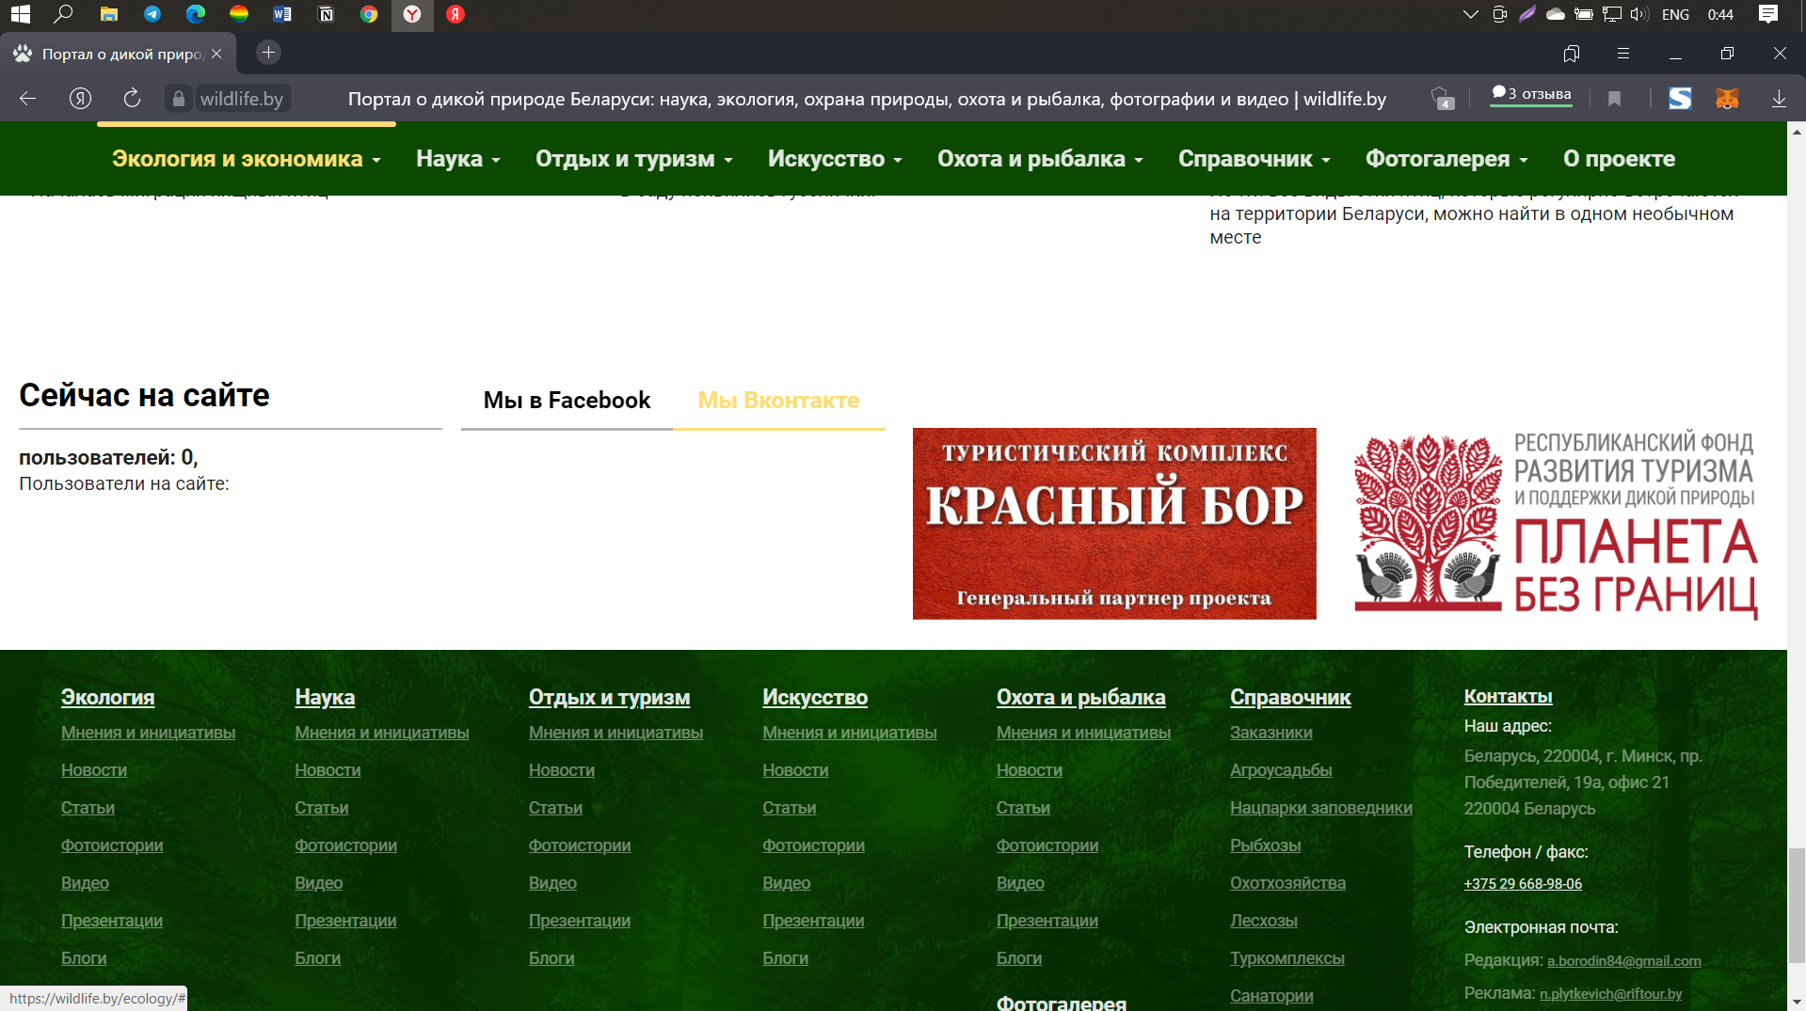

**ID: 006**

Summary: Wrong display menu

Enviroment: Windows 10, Yandex Browser

Severity: Trivial

Priority: Low

Assignee: Мядель Тимофей Дмитриевич

Steps to reproduce: 1. Go to main page <https://wildlife.by/>

2. Scroll the page to the mid

3. Scroll up

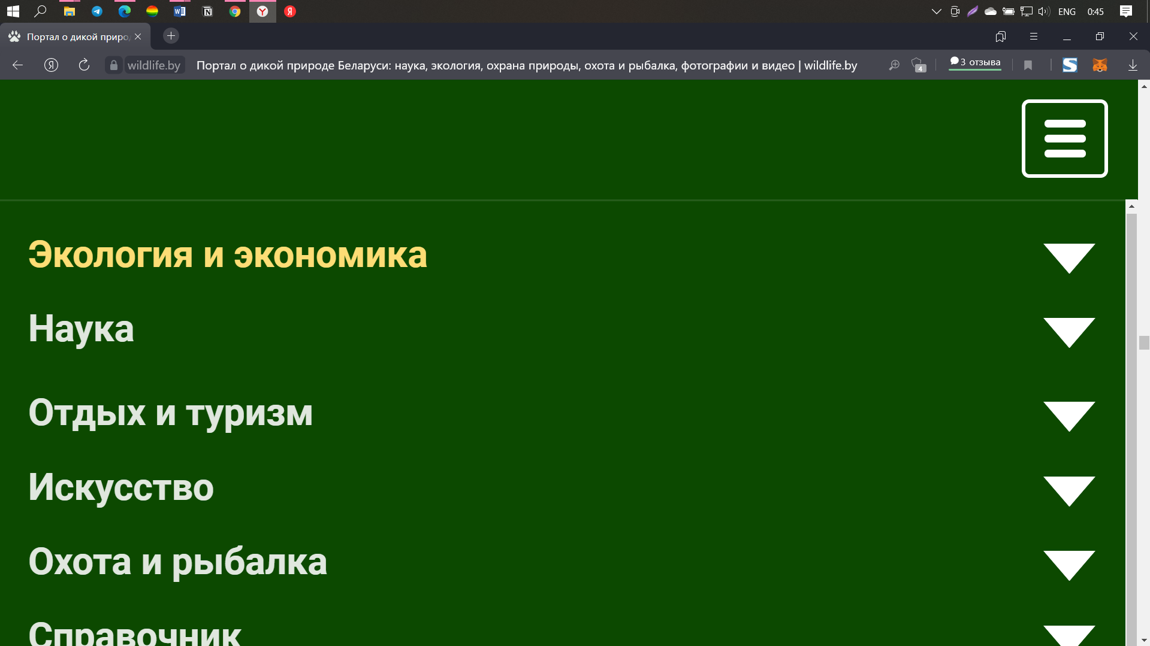

**ID: 007**

Summary: Menu jump when scrolling down

Enviroment: Windows 10, Yandex Browser

Severity: Trivial

Priority: Low

Assignee: Мядель Тимофей Дмитриевич

Steps to reproduce: 1. Go to main page <https://wildlife.by/>

2. Scroll the page

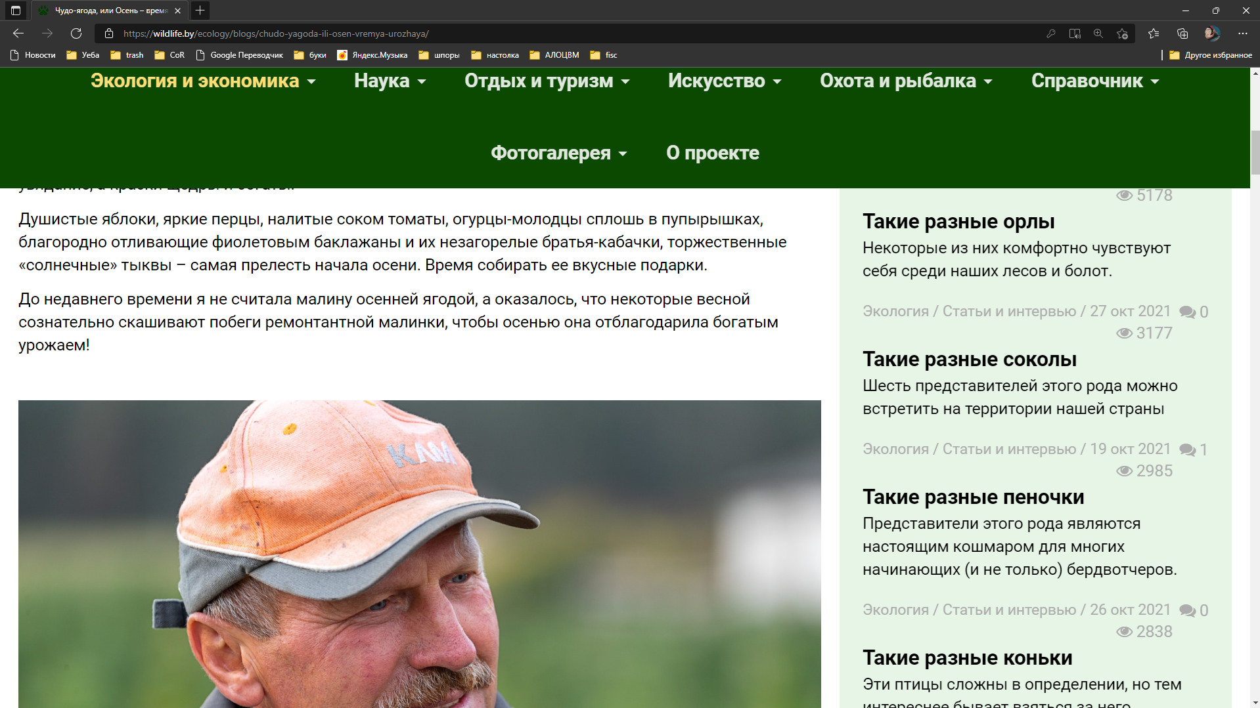

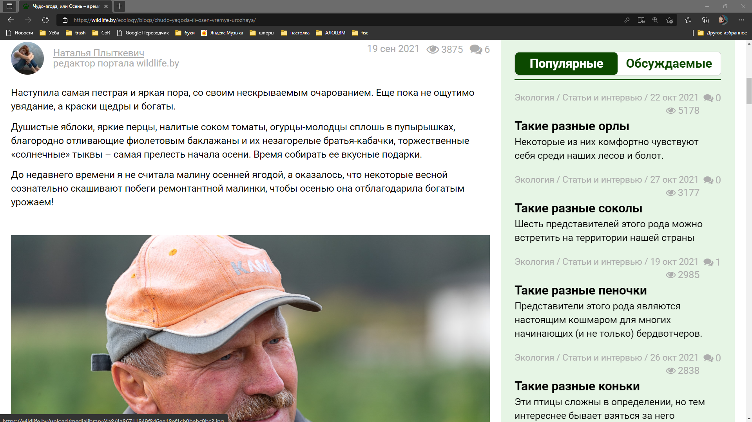

**ID: 008**

Summary: Menu jump when scrolling down

Enviroment: Windows 10, Yandex Browser

Severity: Trivial

Priority: Low

Assignee: Мядель Тимофей Дмитриевич

Steps to reproduce: 1. Go to main page <https://wildlife.by/>

2. Scroll the page to the bottom

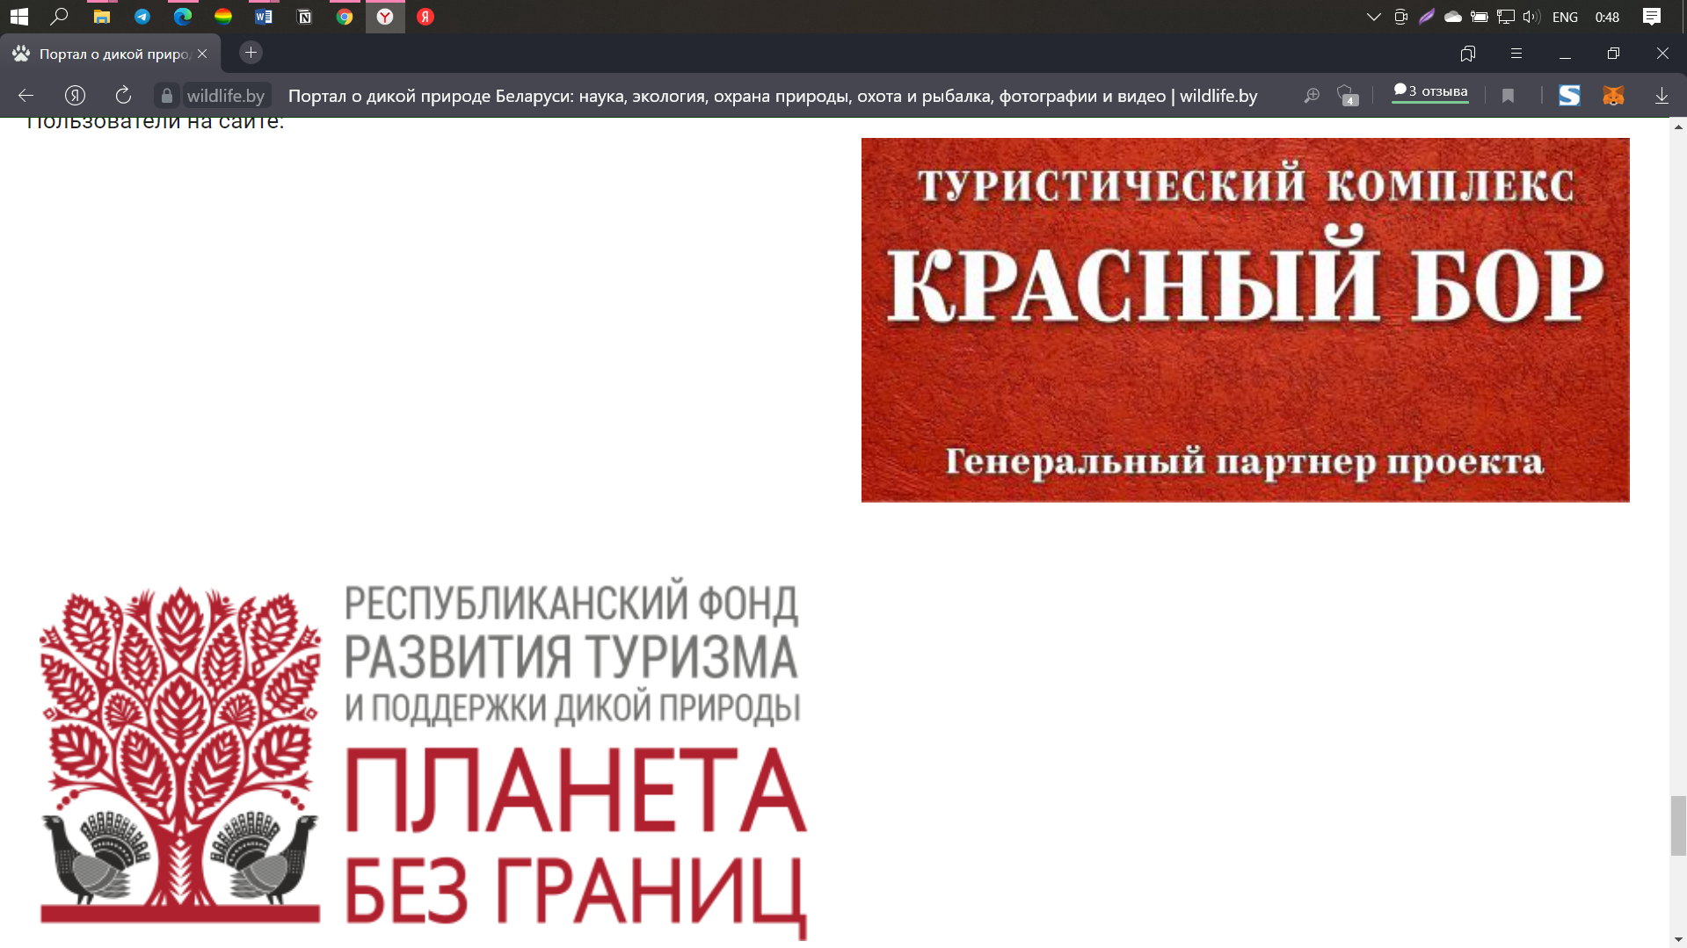

Enviroment: Windows 10, Microsoft Edge

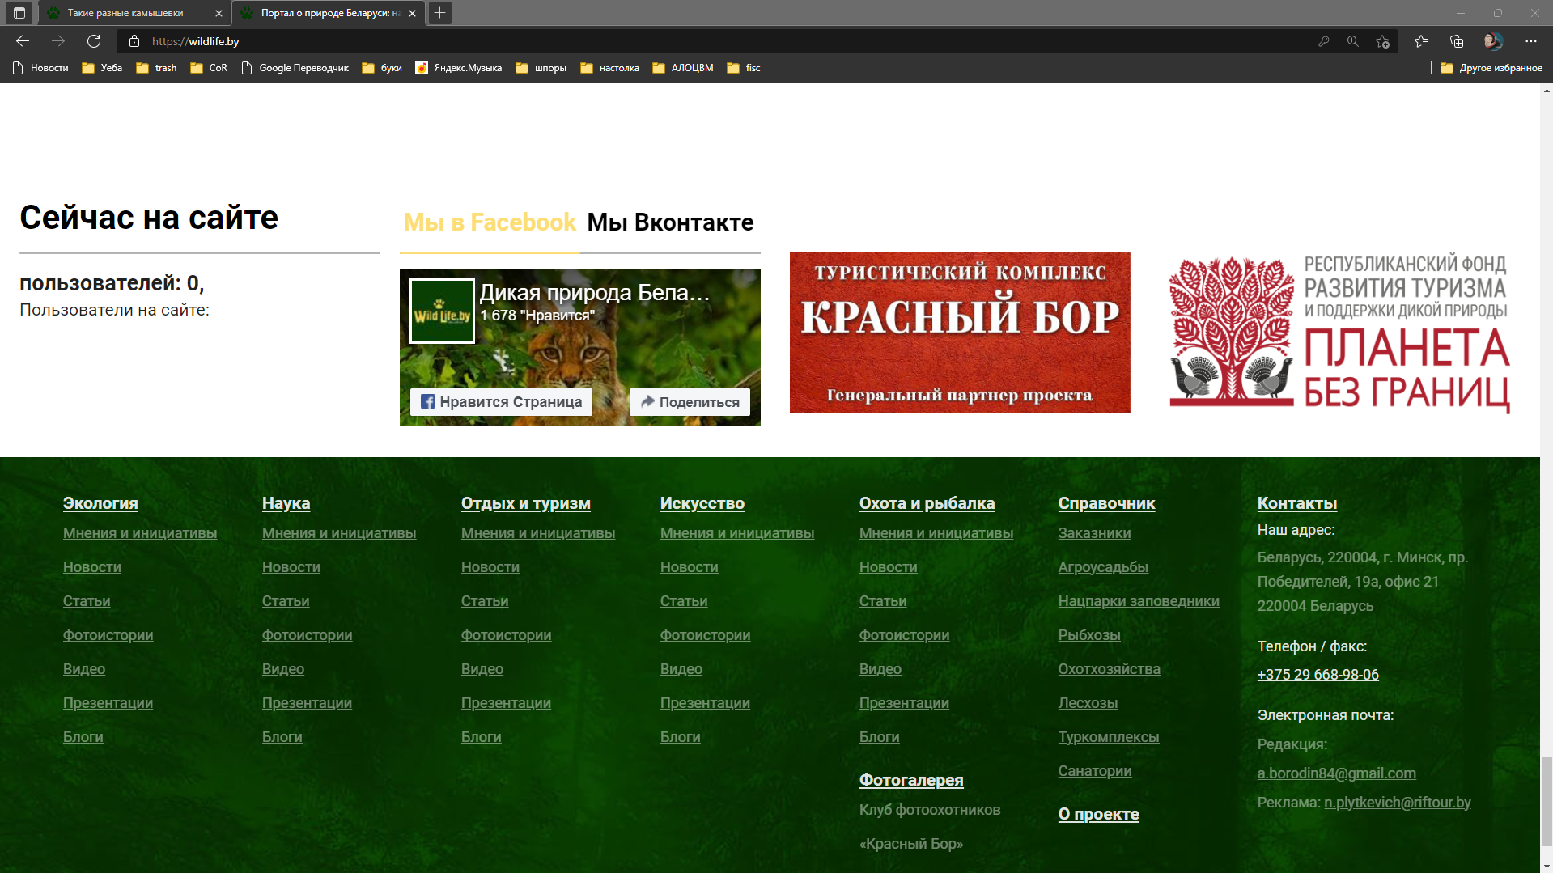

**ID: 009**

Summary: Empty “Фото недели” and same photos at “Фото дня”

Enviroment: Windows 10, Yandex Browser

Severity: Trivial

Priority: Low

Assignee: Мядель Тимофей Дмитриевич

Steps to reproduce: 1. Go to main page <https://wildlife.by/>

2. Scroll the page to the bottom

